

Visual Programming
Lab #1
SUBMITTED BY:
UBAID AHMAD
ROLL NO:
2410-0011
SUBMITTED TO:
Sir Aaish Khan
DATE:
22/09/2025

Task 1
- Program that prints student details including their full name, and current semester along with courses.
Code:
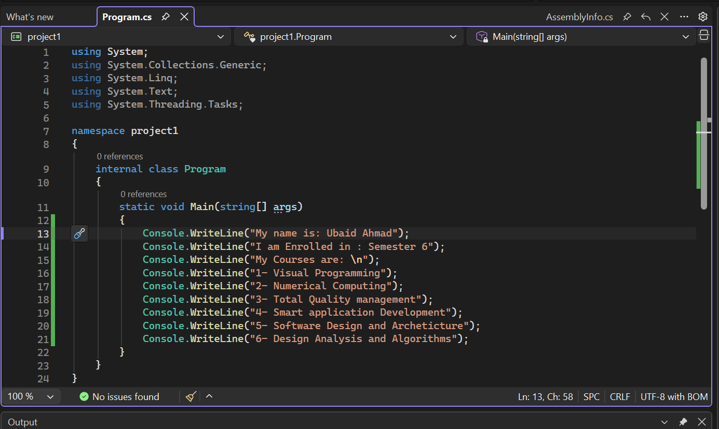
Output:
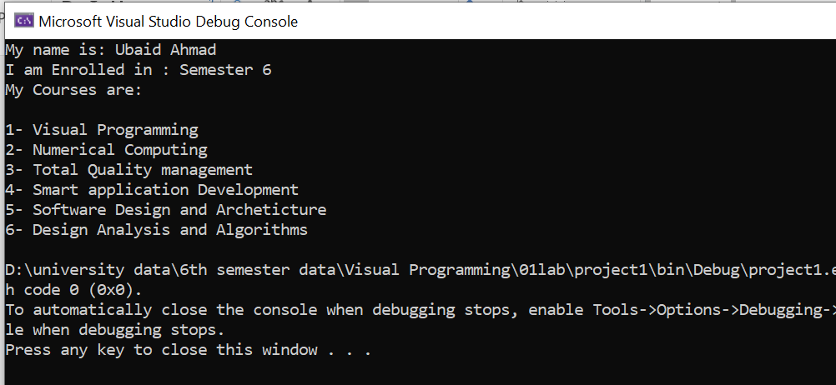
Task 2:
Program that prints pyramid of stars
Code:
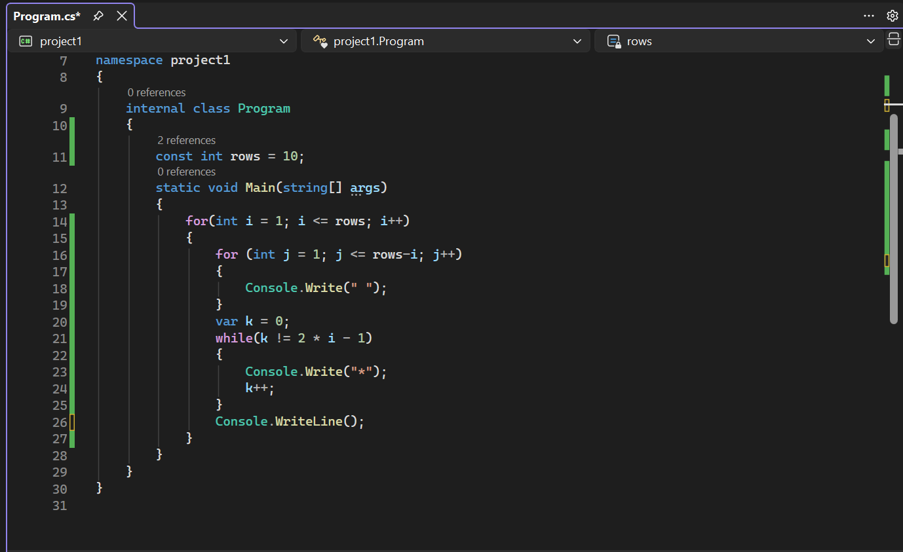
OutPut:
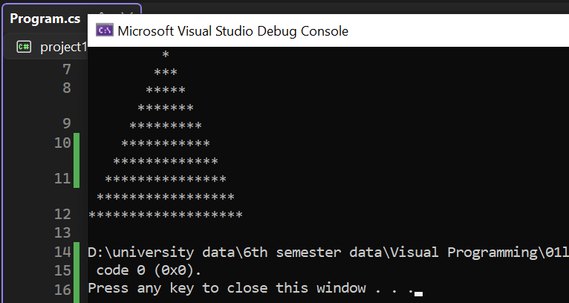
END!

